Blue Dragonfly Recurring Billing

Blue Dragonfly Recurring Billing allows you to create recurring bills that will automatically generate invoices for customers based on the schedule and frequency that you define.

As quickly as you can enter a customer invoice in Dynamics 365 Business Central, you can create a Recurring Bill that will automatically generate an invoice each month, quarter, or year on the date that you specify.

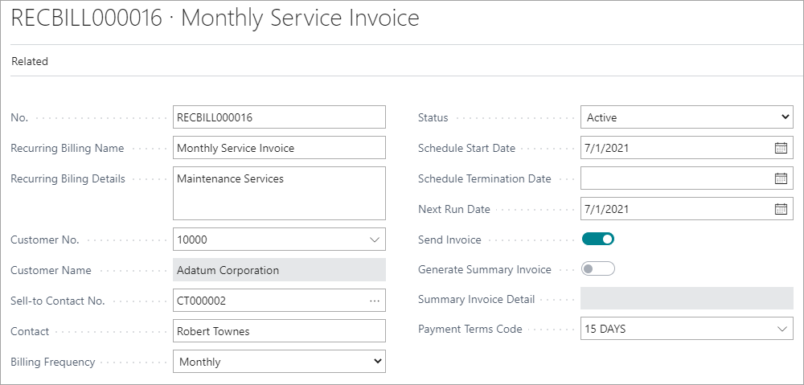

No need to remember to enter your recurring invoices. Active Recurring Bills will have invoices generated automatically on the specified date.

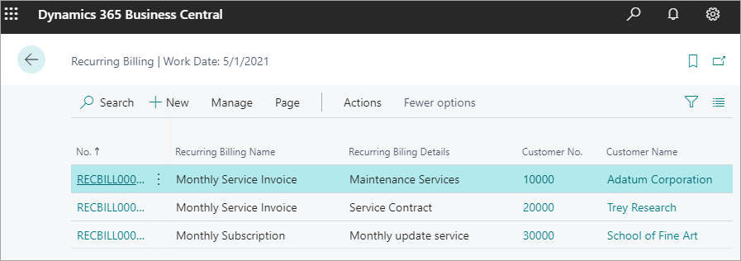

Blue Dragonfly Recurring Billing also allows you create a Sales Invoice on demand for an existing Recurring Bill and copy an existing Recurring Bill to save time.

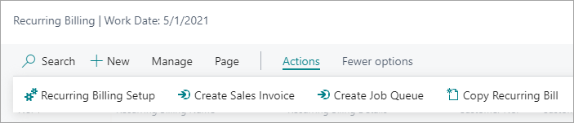

Supported Editions

This app supports both the Essential and Premium editions of Microsoft Dynamics 365 Business Central.

Supported Countries:

United States

Supported Languages

This app is available in English (United States).

