Installation

The Recurring Billing installation process automatically creates the following items:

- Recurring Billing database tables
- Recurring Billing pages
- Recurring Billing number series
- Recurring Billing Job Queue Entry

Setup Page

- Search for “recurring billing”
- Open Recurring Billing Setup Page
- Verify setup page fields are populated

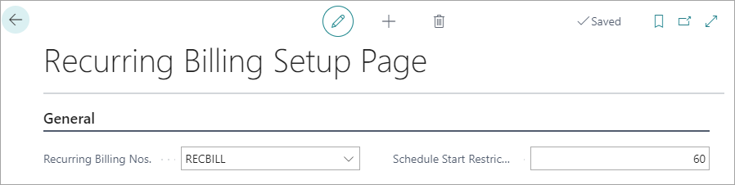

- Verify No. Series is valid, with appropriate Starting Date

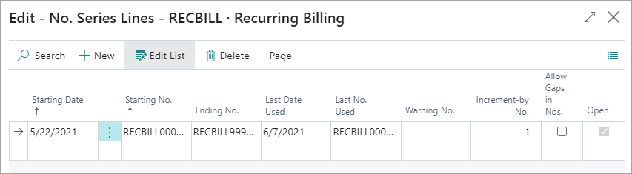

- Confirm or update the Schedule Start Restriction number

Recurring Bill

Create New Recurring Bill

Search for “recurring billing”

Click on the Recurring Billing List page link to view existing Recurring Bills.

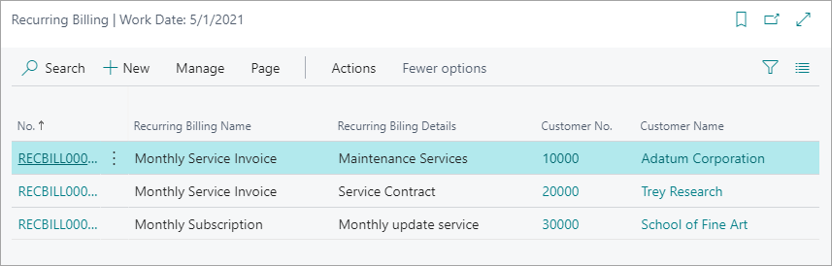

Click on the New button to create a new Recurring Bill.

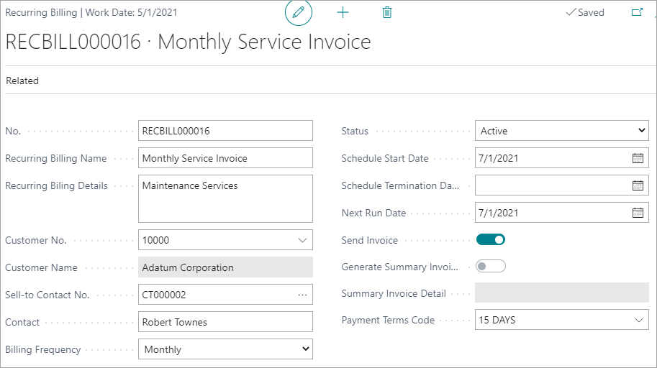

Populate the fields on the Recurring Billing page.

General

No. | Default value should display automatically based on No. Series in RB Setup
Name | Enter a name to describe the Recurring Bill
Details | Enter any additional details to identify the Recurring Bill. (250 characters)
Customer No. | Choose an existing customer
Customer Name | Read only value should populate based on Customer No selection
Sell-to Contact No. | Value should populate based on Customer Contact Code field value
Contact | Value should populate based on Sell-to Contact No. value
Billing Frequency | Choose a pre-defined value: Monthly, Quarterly, Annual
Status | Choose a pre-defined value: Draft, Active, Trial, Cancelled, Hold, Terminated
Schedule Start Date | Enter a date for the start of the billing or subscription period.
Schedule Termination Date | Optional: Enter an end date for the billing or subscription period. Invoices will not be generated after this date. This date must be later than the Schedule Start Date
Next Run Date | Enter a date when the next invoice should be generated.  This date must be equal to or later than the Schedule Start Date
Send Invoice | FUTURE RELEASE: Enable this option to automatically send generated invoices using the delivery method setup in Customer “Document Layouts”
Generate Summary Invoice | FUTURE RELEASE: Enable this option to create invoices with a single “summary” line item with the invoice subtotal amount. When this option is enabled, any line items setup on the Recurring Bill will not show on the invoice sent to the customer.  Send Invoice must be enabled before Generate Summary Invoice can be enabled
Summary Invoice Detail | FUTURE RELEASE: Enter the line description that will be included on invoice sent to the customer when “Generate Summary Invoice” option is enabled
Payment Terms Code | Value should populate with default payment terms code from Customer

Shipping and Billing

Select the appropriate Ship-to and Bill-to address values.

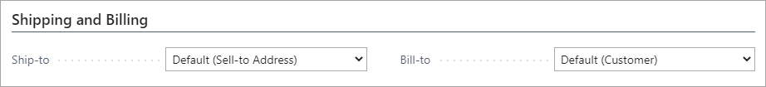

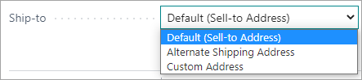

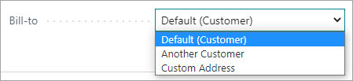

Recurring Billing Lines

Enter lines for the Recurring Bill.

In this release, only Service and Non-Inventory Items are supported.

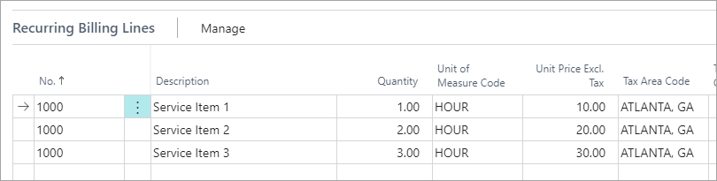

Recurring Billing Details

Verify the Tax Area Code, Tax Liable, and Tax Exemption No values that have defaulted from the customer.

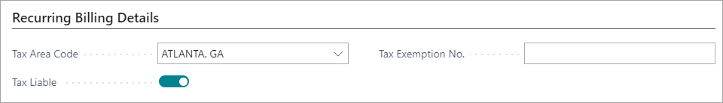

Delete Recurring Bill

To delete a Recurring Bill, open the bill and click on the Delete icon at the top of the page.

If an invoice has been generated for the Recurring Bill, the bill cannot be deleted.

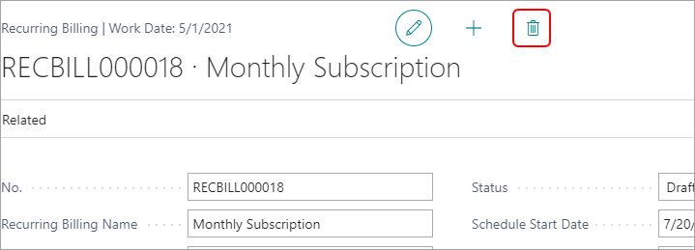

Manually Create Invoice from a Recurring Bill

Select a record on the Recurring Billing List page

Click on the Actions button

Click on Create Sales Invoice

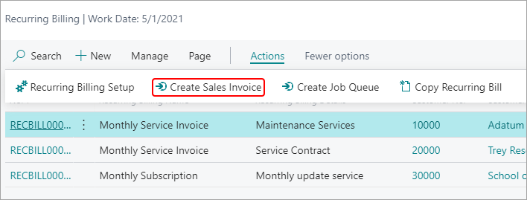

Run Job Queue Entry to Create Recurring Bill Invoices

Search for “job queue”

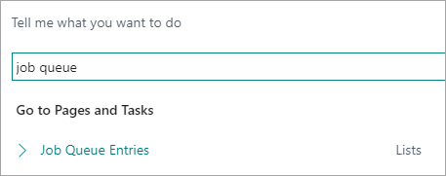

Select the Job Queue Entries list page

Select the Run Recurring Billing Job row

Click the Run once (foreground) button
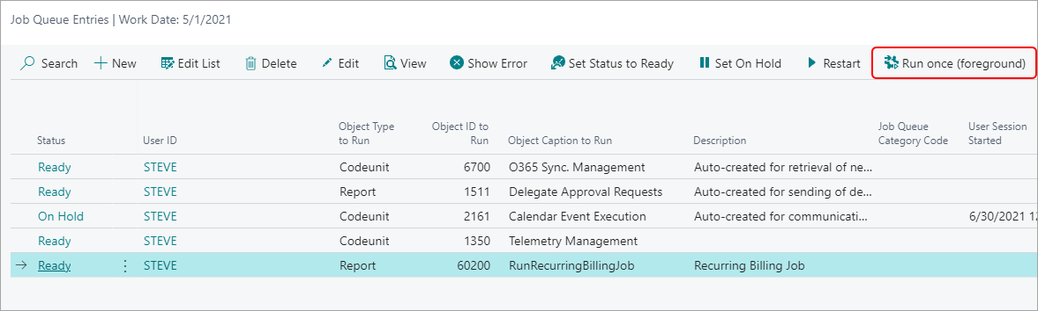

Or click on Edit to view the Job Queue Entry Card

Click on Run once (foreground)

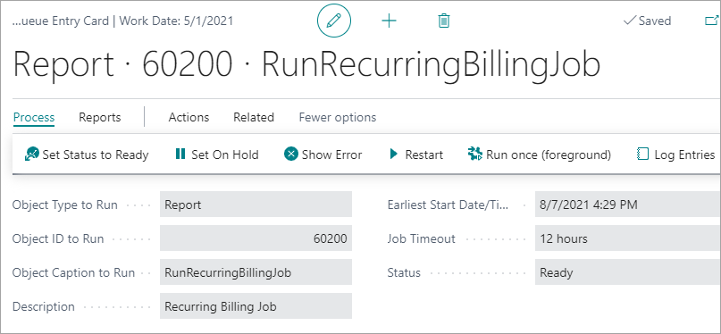

Version History

Date | Version | Note
8/6/2021 | 1.0 | Initial version

